Daniel Marzari

450

Cairn University School of Business

CIS122 Essentials of Networking

Project #4

Project objective: Prepare the network infrastructure of a new site.

Equipment used:

|  |  |  |  |  |
| --- | --- | --- | --- | --- |
| Equipment Description | Vendor | Vendor Item # | Retail price | Actual price (if known) |
| 24 Port Switch (x1) | TRENDnet | TEG-S24D | $87.99 | $87.99 |
| 16 Port Switch (x3) | TRENDnet | TE100-S16Dg | $34.04 | $68.08 |
| 8 Port Switch (x1) | TRENDnet | TE100-S8 | $15.99 | $31.98 |
| Server Rack (x1) | Newegg | 9SIAFM16WF8684 | $639.99 | $639.99 |
| Patch Panel (x1) | Newegg | 9SIAHFE86U1271 | $23.99 | $23.99 |
| Cat 5e Cable 1000ft (x2) | NavePoint | 00400622 | $39.95 | $78.90 |
| Server (x1) | Newegg | N82E16816139116 | $2,228.62 | $2,228.62 |
| Cable Raceway 5ft (x60) | Newegg | 9SIA6ZP6WY9262 | $17.99 ($15.12) | $907.20 |
| Wall Mounts (65+) | Monoprice | 6725 | $0.47 | $30.55 |
| Labor (per 10 lines 200 ft) | National Avg. |  | $750 | $2,000.00 |

Detailed list of software and operating platforms used, including version numbers and licensing requirements:

None.

Network diagram:

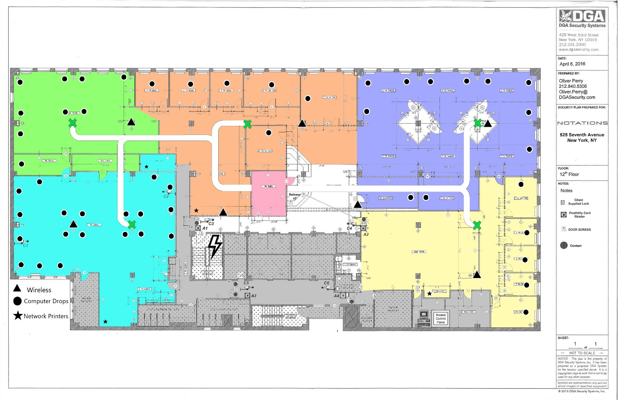

Configurations:

The Demarc, symbolized by the lightning bolt on the stairwell, will run right into the telecommunications room (pink) for access to the internet. Horizontal runs of Cat5e/6 cable from the telecommunications room (pink) to central locations in each zone (color coded teal, green, rust, purple, and mustard). These central locations are marked by a green “X”. Where these cables end, the wires connect to a switch capable of handling the number of connections in that zone: 21 in blue which has a 24-port switch, 10 in green which has a 16-port switch, 9 in rust which has a 16-port switch, 13 in purple which has a 16-port switch, and 7 in mustard which has an 8-port switch. The black circles represent spots for a drop and wall mount. Cabling is run from the centralized switch to each of these locations in a star topology. The black triangles represent wireless access points. And lastly, the black stars are network printers which are located in conveniently open areas for ease of use.